Stor2rrd

# Introduction

STOR2RRD is an open-source software tool that is used for monitoring and reporting performance in storage systems, SAN switches, and LAN switches. It is developed by the Czech company XoruX.

This is dockerized version of single XoruX application - STOR2RRD. It's based on the latest official Alpine Linux with all necessary dependencies installed.

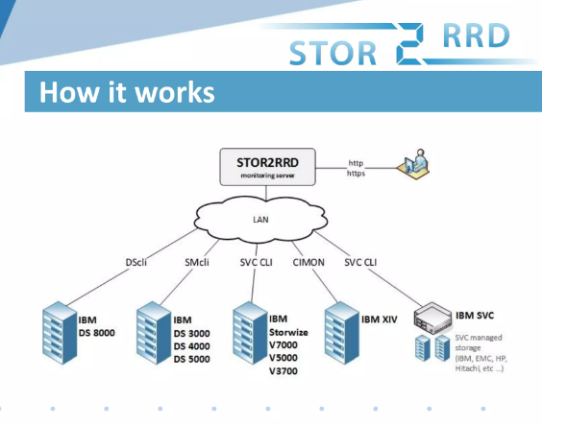

STOR2RRD will provide you a single web-based interface where you can view the performance of all different systems.STOR2RRD is one of the best tools offers you end-to-end views of your storage environment including LAN and SAN. It can save you significant money in operation monitoring and by predicting utilization bottlenecks in your virtualized environment.

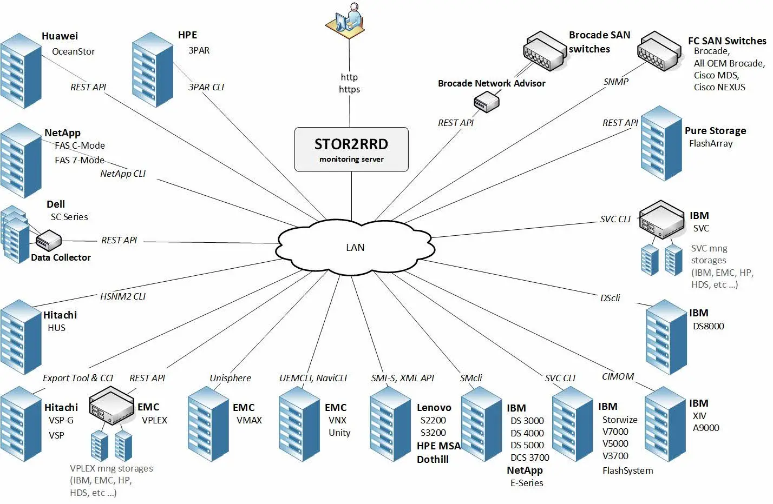

Also you can generate policy-based alerts, view the overall health status of your systems, provide capacity reports and forecasting data.

Free performance monitoring tool for storages with following features

Create storage utilization graphs for monitored storages

Create historical and nearly on-line utilization graphs

It graphically presents Iow rate, data throughout, response times

front end and back end data

Ports, pools, arrays, ranks, mdisks volumes drives

Host aggregated graphs

The full list of supported systems is significant and includes both storage systems and switches

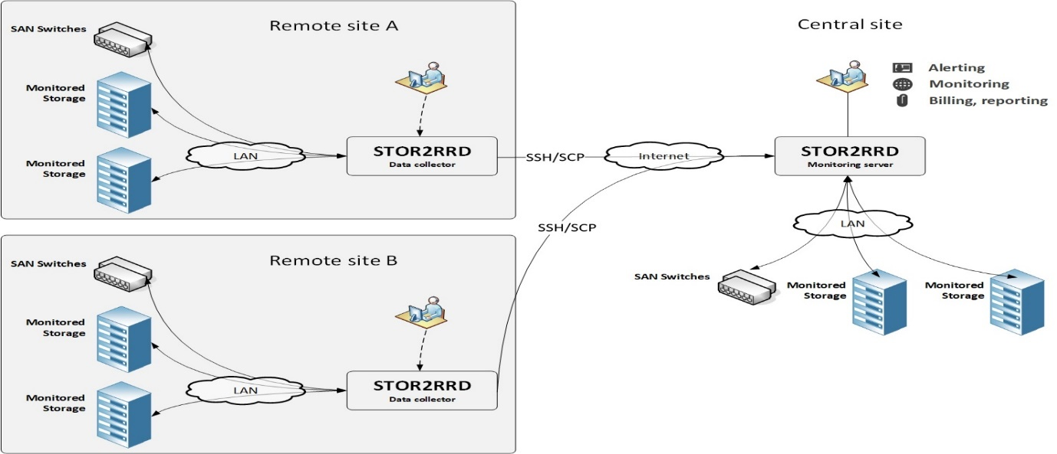

STOR2RRD is free software which you can redistribute it and/or modify it under the terms of the GNU General Public License. For customers, under support, there is distributed the enterprise edition with additional benefits

|  |  |
| --- | --- |
| Website | https://stor2rrd.com/ |
| Organization/Foundation Name | XoRux |
| License | GNU General public license |
| Open/Proprietary | Open |
| Source Path(if open source) | https://github.com/Silvanus19/stor2rrd.git |
| Brief Description | Stor2rrd is a free Storage, SAN, LAN Performance and Capacity Monitoring Tool. Analyze key infrastructure performance metrics of your Storage, SAN and LAN devices. Prognosis for all your Infrastructure. Monitor and troubleshoot pro-actively. Optimize your mission-critical IT infrastructure. |

# Project Summary

# Project Details

## Key Features

Real-time storage, SAN and LAN performance visibility in multi-vendor environment

Historical reporting (graph, CSV, PDF, XLS)

Alerting based on performance thresholds

Event monitoring

You can find utilization of any attached storage in a simple graphical form comprehensible to anyone from technician to management level

Free to use. You do not need to purchase expensive commercial solutions

Optional Paid support

Simple administration

Enterprise edition

STOR2RRD will provide you a single web-based interface where you can view the performance of all different systems. STOR2RRD is one of the best tools offers you end-to-end views of your storage environment

It can save you significant money in operation monitoring and by predicting utilization bottlenecks in your virtualized environment.

STOR2RRD is free software which you can redistribute it and/or modify it under the terms of the GNU General Public License

We are building a new generation of our infrastructure-monitoring software based on Microservice architecture, TimescaleDB React and others.

## Architecture

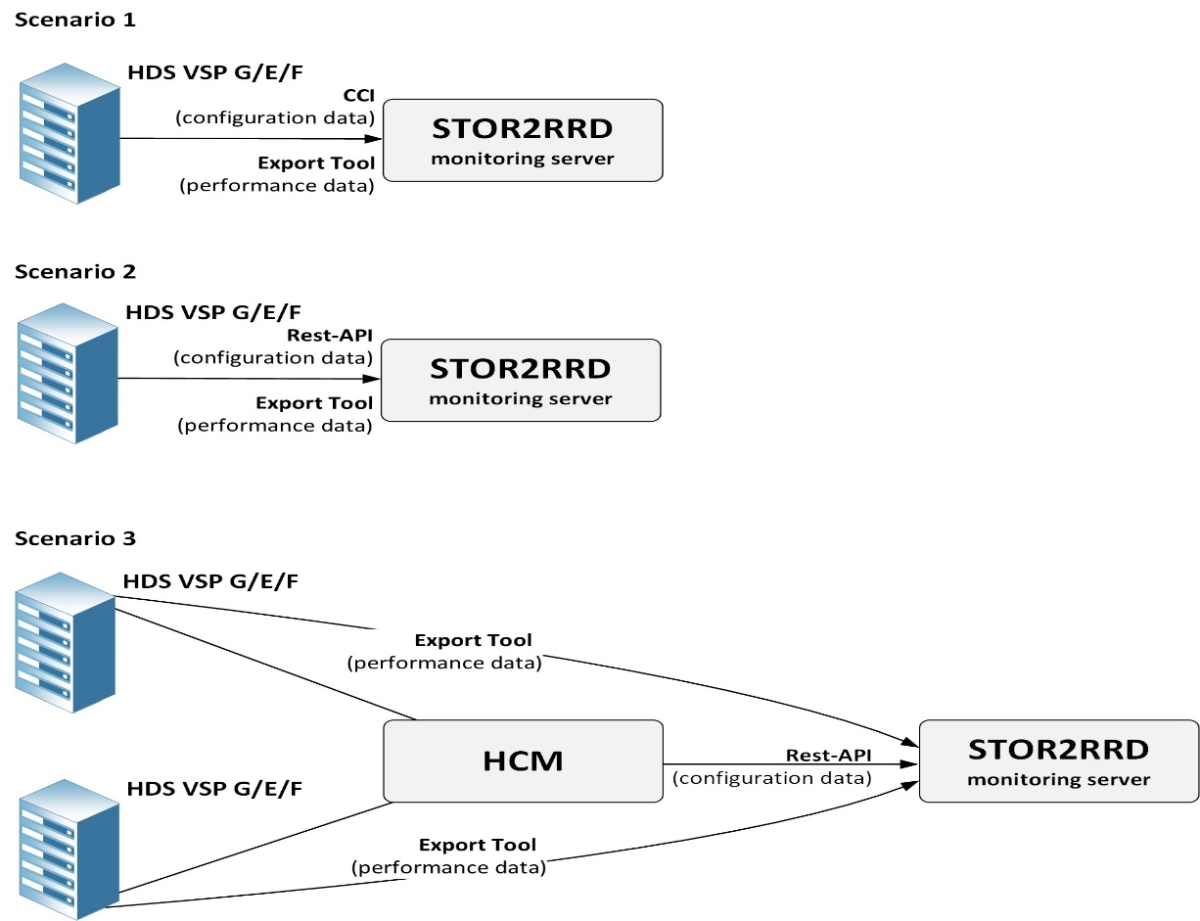

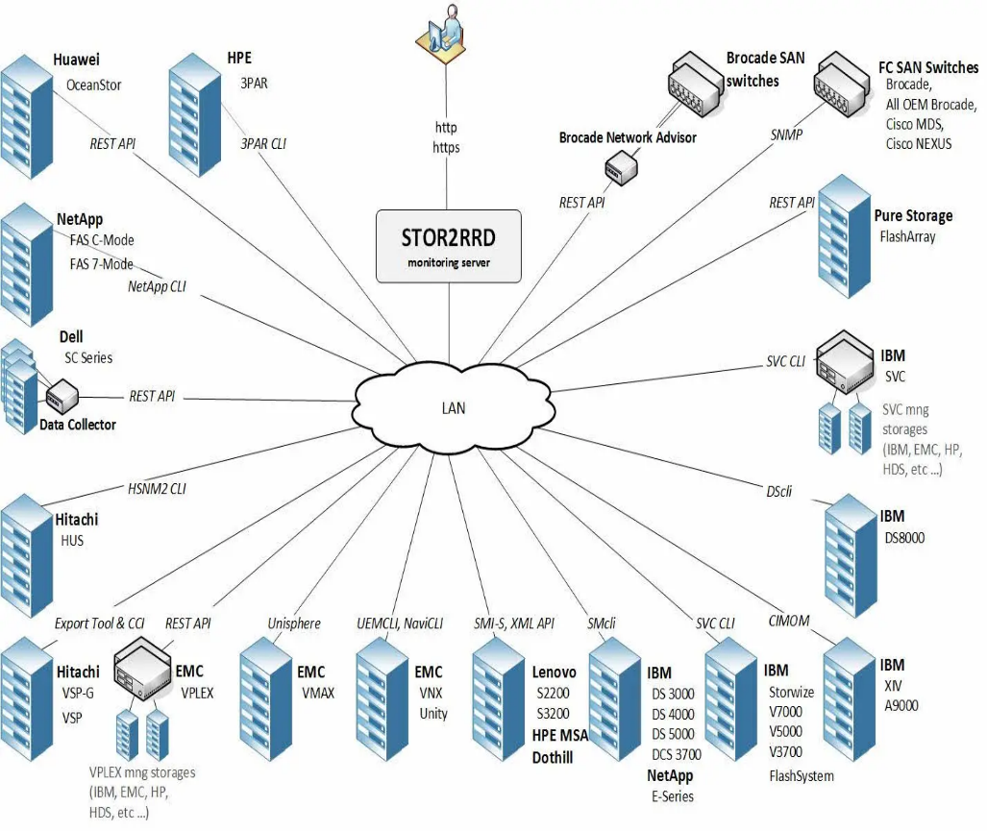

Stor2rrd is an open-source monitoring and reporting tool for SAN and LAN devices. It supports most vendors products such as EMC, Brocade, HPE and others.

The full list of supported systems is significant and includes both storage systems and switches

## Current Usage

STOR2RRD is an open-source software tool that is used for monitoring and reporting performance in storage systems, SAN switches, and LAN switches. It is developed by the Czech company XoruX.

The software is compatible with various systems by Dell, EMC, Hitachi, HPE, IBM, NetApp, Synology, and others. It is also integrated with various storage systems, including Tatlin, Unified.

The software is being used by organizations and products in various industries and brands such as

IBM, NetApp, EMC^2, Fujitsu, Infinidat, Huawei, Hitachi, VM ware, Microsoft partner, red hat.

It offers value added resellers program is open for partners who want to be more agile partners who want to address new potential business.

Partners who want to get better knowledge of environment of their customers

Partners who need to monitor customers environment remotely

The value added resellers program is opened for partners who want to be more agile

Some popular resellers are

Converge one

Champion

Fortra

Duosis

Corus360

Intendo

Netria

Softine

Syssoft

Impromat

## Technical Details

## Performance part have 3 predefined time ranges (last day/week/month) with crucial metrics IOPS / Data throughput / Latency

## STOR2RRD monitors IO and data throughput of all volumes and creates graphs per volume and aggregated with all volumes. In order to make aggregated graphs easy readable it comes with its own approach how to place all volumes into single aggregated graph.

## Capacity is reported per pool

Real-time storage and SAN performance visibility in multi-vendor environment Historical reporting (graph, CSV, PDF, XLS) Alerting based on performance thresholds Event monitoring

Optional monitoring

It is intended as a front end tool for admins

Quick search of actual and historical utilization

Searching of unusual behavior

Alerting

Historical Reporting

To see trends based on historical data

Create reports for other teams and management

### Project comparison

LPAR2RRD is an open-source software tool that is used for monitoring and reporting performance of servers, clouds and databases. It is developed by the Czech company XoruX

Microsoft Storage Spaces Direct (S2D) monitoring This is monitored by our sister product called LPAR2RRD as part of its Microsoft HyperV cluster monitoring.

### LPAR2RRD is an Open Source software

LPAR2RRD is published as an open source software under the General Public License version 3

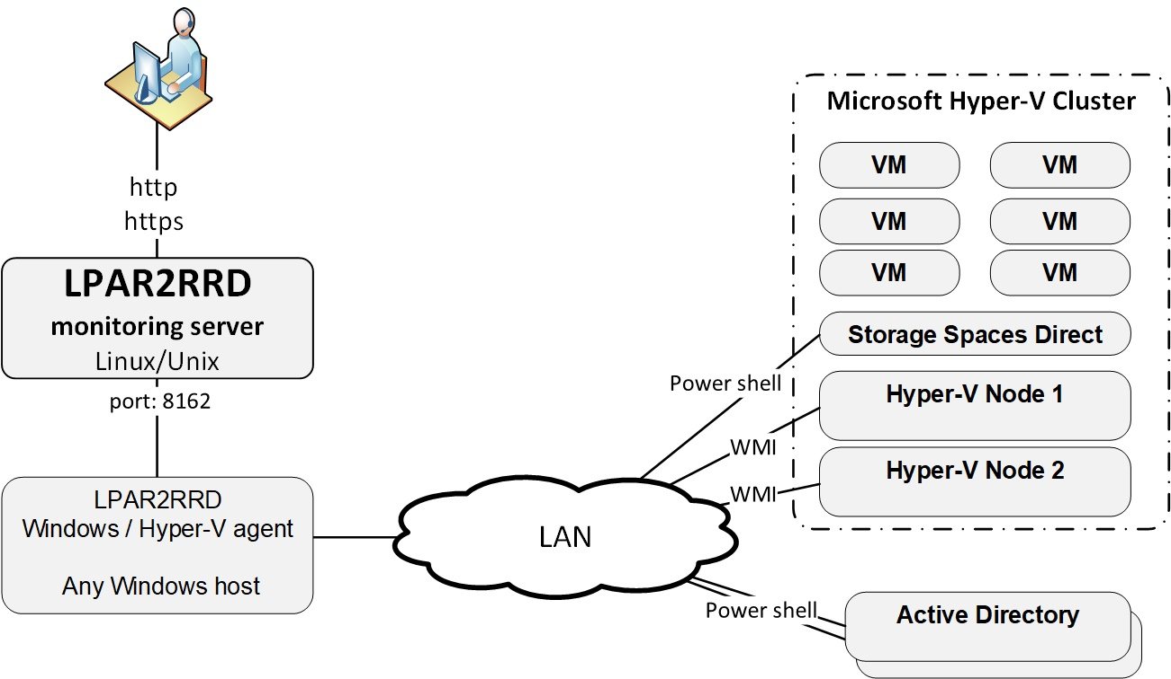

The software tool is designed to monitor and report on server virtualization utilizations. It produces utilization graphs, reports, or alerts of physical or virtual servers on CPU, memory, IOPS, and many other depending on specific virtualization platform.

It also supports database engines as Oracle Database, PostgreSQL or containerization platforms like OpenShift or Docker. Cloud technologies are supported as well.

The software is compatible with various systems by IBM Power Systems, IBM , VMware, Nutanix, Oracle VM, Oracle Solaris, oVirt / Red Hat Virtualization, XenServer, Microsoft Hyper-V, Linux, Oracle Database, PostgreSQL Database, Microsoft SQL Server, Amazon Web Services, Microsoft Azure, Google Cloud, Apache CloudStack, Kubernetes, Red Hat OpenShift, Docker, Huawei FusionCompute, and Proxmox.

### Any other information

The tool offers you end-to-end views of your storage environment including NAS and SAN and can save you significant money in operation monitoring and by predicting utilization bottlenecks in your virtualized environment.  
You can also generate policy-based alerts, view overall health status of your systems, provide capacity reports and forecasting data.

Analyze key infrastructure performance metrics of your Storage, SAN and LAN devices.  
Prognosis for all your Infrastructure.  
Monitor and troubleshoot pro-actively.  
Optimize your mission-critical IT infrastructure.

### Reference / Acknowledgements

[**https://stor2rrd.com/**](https://stor2rrd.com/)

[**https://lpar2rrd.com/**](https://lpar2rrd.com/)

**-----------------------------End of the template--------------------------------**